> library(facerec)

> facerec_init()

> library(jpeg)

> library(magick)

> library(image.libfacedetection)

> image <- image_read("C:/Users/Hero Ozagho/Desktop/hO/HO 141.jpg")

> faces <- image_detect_faces(image)

> faces

$nr

[1] 5

$detections

x y width height confidence landmark1_x landmark1_y landmark2_x landmark2_y

1 565 142 36 48 99 575 161 591 161

2 410 78 30 38 99 418 92 433 92

3 462 78 30 43 99 468 95 481 96

4 316 141 40 55 99 329 160 348 165

5 329 62 31 38 99 340 76 353 76

landmark3_x landmark3_y landmark4_x landmark4_y landmark5_x landmark5_y

1 583 171 577 178 591 177

2 426 100 419 106 432 105

3 473 104 469 110 480 111

4 338 172 328 179 344 183

5 349 81 341 88 354 88

attr(,"class")

[1] "libfacedetection"

> plot(faces, image, border = "red", lwd = 7, col = "white")

format width height colorspace matte filesize density

1 JPEG 800 533 sRGB TRUE 0 72x72

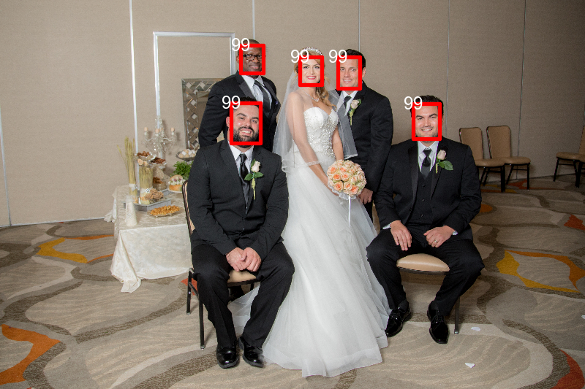

https://cran.rstudio.com/bin/windows/Rtools/

Warning in install.packages :

package ‘image.libfacedetection’ is in use and will not be installed

> allfaces <- Map(

+ x = faces$detections$x,

+ y = faces$detections$y,

+ width = faces$detections$width,

+ height = faces$detections$height,

+ f = function(x, y, width, height){

+ image_crop(image, geometry_area(x = x, y = y, width = width, height = height))

+ })

> allfaces <- do.call(c, allfaces)

> allfaces

format width height colorspace matte filesize density

1 JPEG 36 48 sRGB FALSE 0 72x72

2 JPEG 30 38 sRGB FALSE 0 72x72

3 JPEG 30 43 sRGB FALSE 0 72x72

4 JPEG 40 55 sRGB FALSE 0 72x72

5 JPEG 31 38 sRGB FALSE 0 72x72



> library(magick)

> library(image.libfacedetection)

> image <- image_read("C:/Users/Hero Ozagho/Desktop/hO/HO2.jpg")

> faces <- image_detect_faces(image)

> faces

$nr

[1] 1

$detections

x y width height confidence landmark1_x landmark1_y landmark2_x landmark2_y

1 132 94 167 214 99 188 179 267 186

landmark3_x landmark3_y landmark4_x landmark4_y landmark5_x landmark5_y

1 232 222 176 243 256 249

attr(,"class")

[1] "libfacedetection"

> plot(faces, image, border = "red", lwd = 7, col = "white")

format width height colorspace matte filesize density

1 JPEG 399 399 sRGB TRUE 0 96x96

> install.packages("magick")

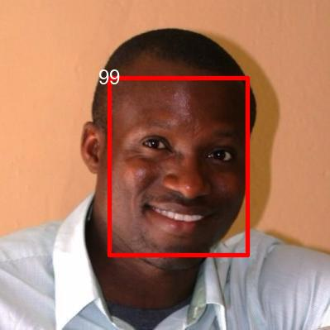

> allfaces <- Map(

+ x = faces$detections$x,

+ y = faces$detections$y,

+ width = faces$detections$width,

+ height = faces$detections$height,

+ f = function(x, y, width, height){

+ image_crop(image, geometry_area(x = x, y = y, width = width, height = height))

+ })

> allfaces <- do.call(c, allfaces)

> allfaces

format width height colorspace matte filesize density

1 JPEG 167 214 sRGB FALSE 0 96x96

>

